**Installation of Nagios in Linux servers and monitoring DB Server**

Step :1

For Stage servers, Login into the Jumpbox server(10.5.110.61). And open the server which we are going to install Nagios.

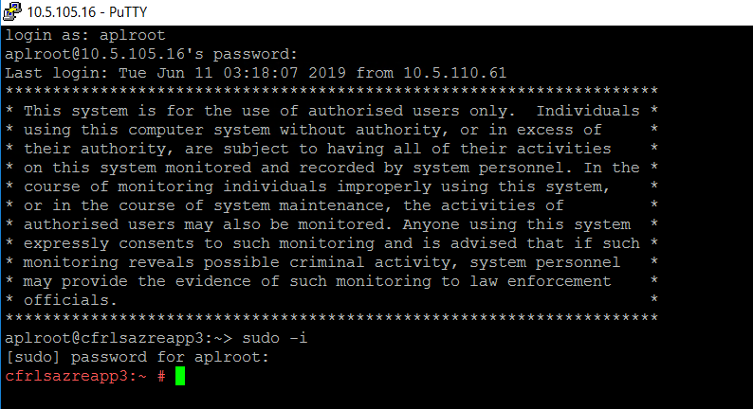

Step :2

Next we need to copy the folder , For that we can copy the files form the existing server where we already installed Nagios(10.5.105.14). To copy the file, We need change the directory into this path **cd /usr/tmp.**

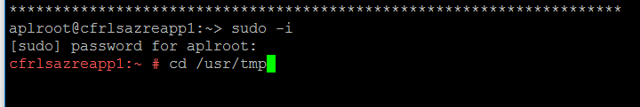

Step :3

Now we need to execute the command for Secure copy, The command is **scp 1ch_send_nrdp.sh send_nrdp.sh aplroot@10.5.105.16:/usr/tmp/**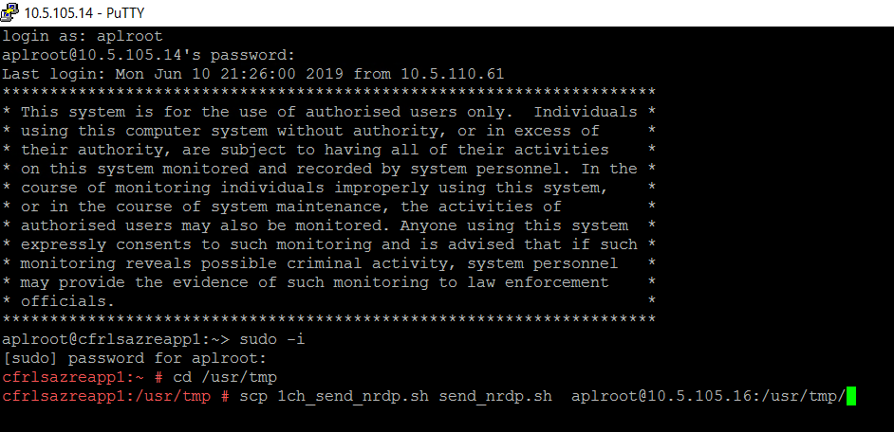

Note: The Ip in the copy command changes depends on which server we are moving the file.

Step :4

After we execute the above command, type **ls** in the server where we copy the file.

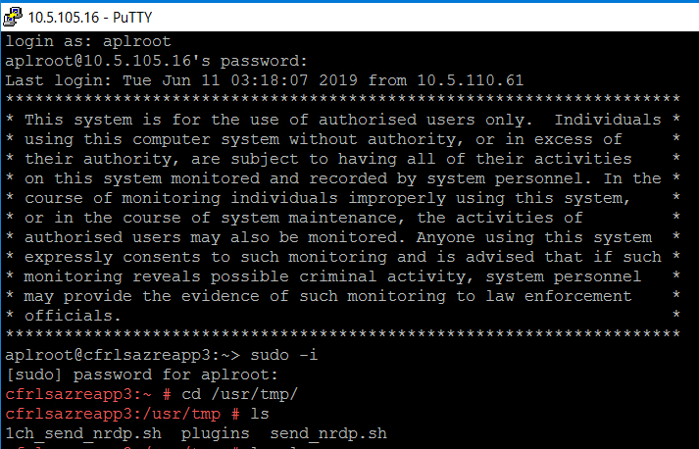

Step :5

Once we successfully copied the file, We need execute the following commands.

1. chown root:root 1ch_send_nrdp.sh send_nrdp.sh
2. cp 1ch_send_nrdp.sh /usr/local/sbin/
3. cp send_nrdp.sh /usr/sbin/
4. cd /usr/local/sbin/









Step :6

vi 1ch_send_nrdp.sh

After executed the view command, We need to modify the hostname and the path using insert option by pressing **I.**

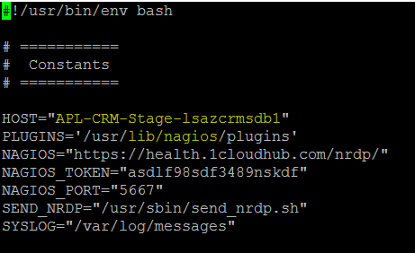

In the highlighted places , we need to change it to the respective hostname and the path file (/usr/tmp/plugins).

Once we changed , save and exit using :**wq** command.

Step :7

Open the Winscp wizard and type the hostname. The username is aplroot and password Admin@1234567

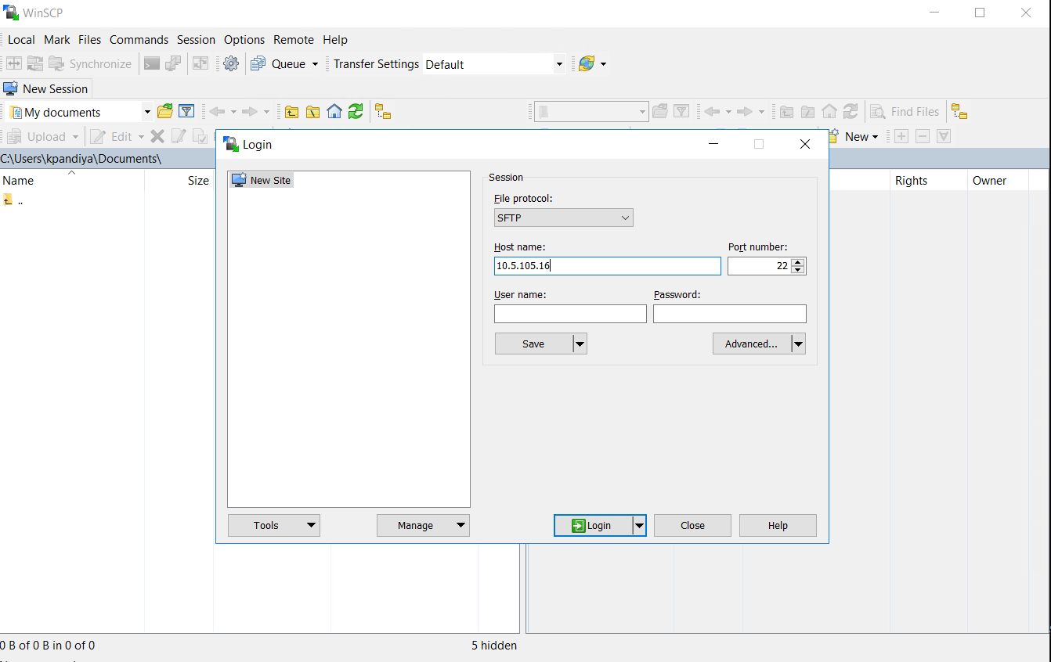

Step :8

Once we logged into the session, we need to drag the plugins folder to tmp location.

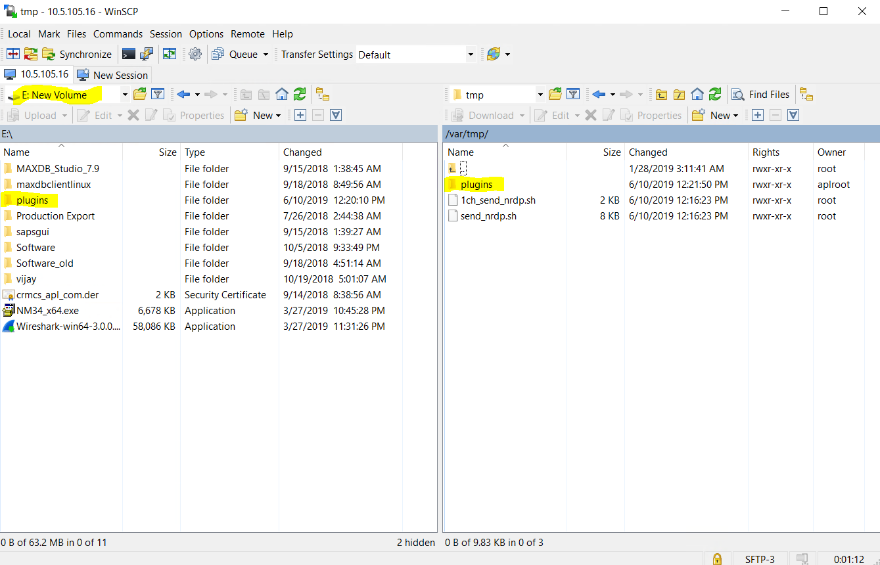

Step :9

After that we need to execute the command **cd plugins** and **ls.**



Step :10

Then we need the change the mode using the following command.

1. chmod 755 custom_check_mem
2. chmod 755 check_load
3. chmod 755 check_procs
4. chmod 755 check_disk









1. df -h

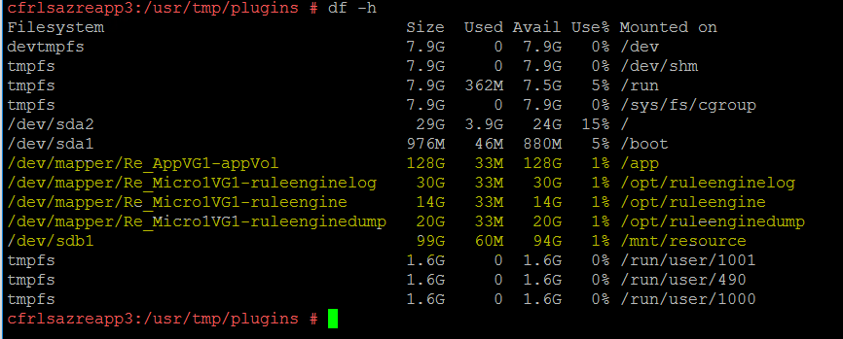

Step :11

Next step we need edit the filesystem using command **crontab -e** and **insert**  the below file system.

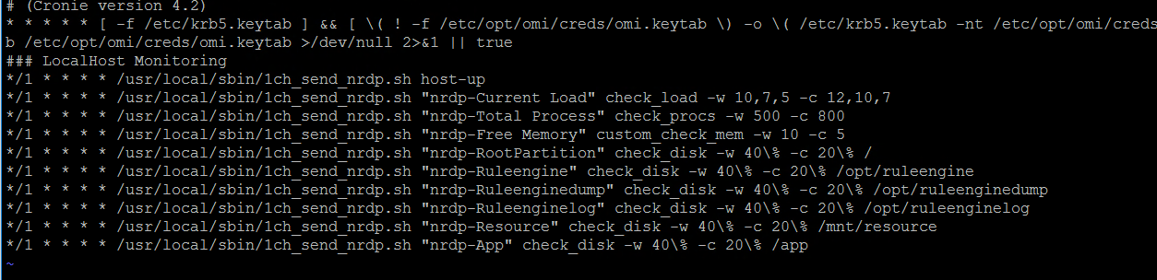

Note: Insert the above file system at the end.

To check crontab -l.

We will enable the DB full backup and differential backup

we will perform health check and enable DB parameters to monitoring in nagios

**Validation:**

Once the installation is successful, we will be able to see the server entry in the Nagios monitoring tool along with the server status

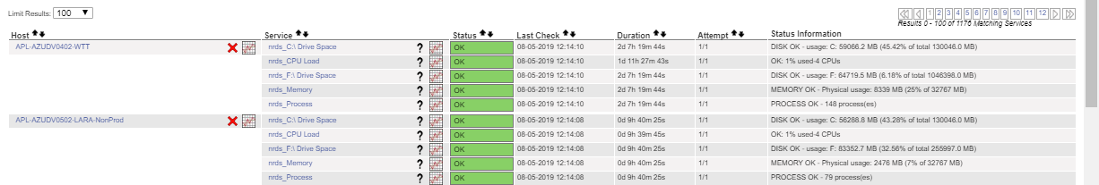

**Backout Plan:**

In case of any failures, the backout plan would be to uninstall the Nagios under crontab -e